Awesome Calculator Challenge Project:

You have now have the skills to create a graphics calculator. Your challenge is to create the best possible calculator app. The more features you add and the cooler your calculator looks, the better. Below are two started samples demonstrating how it can be done. Use them as a starting point or use your own design to complete your calculator. Complete the design template on the next page and hand in this document in the format “lastNameFirstNameAwesomeCalculator”.
Sample #1 : Difficulty = Medium
Code: | Output:
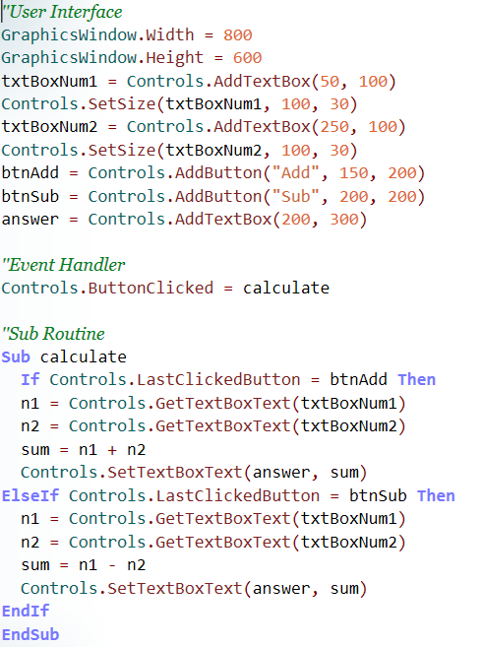 | 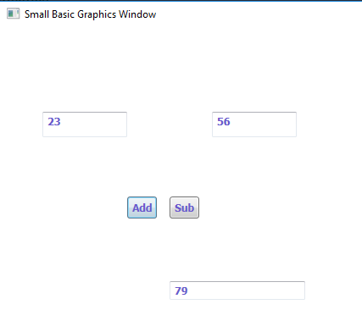

Sample #2: Difficulty = Hard
Code: | Output:
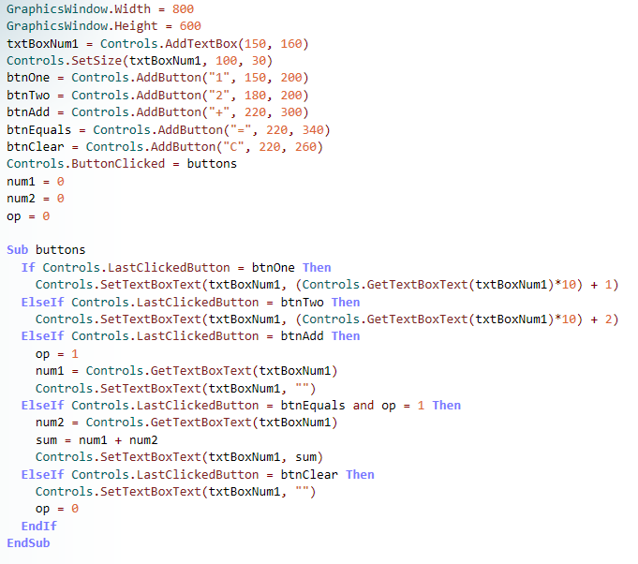 | 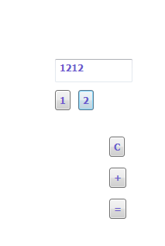
Awesome Calculator Design Template:
Name:
Design (Designer Role): Steps to complete the project are below.

Create (Programmer Role): In this box display your code and output from your program. Use the Snipping Tool to paste your results. Calculate at least one question using each subroutine in your output.

Input: | Output:
Adapt: In this box list any adaptations or challenges you had while making your app.

Appraise (Project Manager Role): Write a short self-evaluation of your project. What did you do well, what could you improve on etc.

