ELT 1010 - Test 2 - Electronics

1. Electricity flows because of
- Differences in amperage
- Differences in voltage
- Differences in potential charge
- Electrical repulsion

2. The difference between conductive and semi-conductive material is
- Diameter
- Resistance
- Magnetic Potential
- Heat dissipation

3. What does this symbol mean in electrical diagrams?
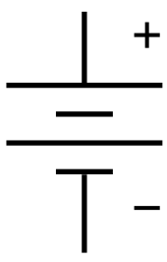
- A battery
- A resistor
- A capacitor
- A charge

4. A parallel circuit has
- More than one battery
- Two routes for electricity
- Batteries put together
- Multiple routes for electricity

5. Voltage is
- The electrical potential difference
- Flow of electric charge
- Amount of electricity
- Ability to store electrical charge

6. Capacitance is
- The electrical potential difference
- Flow of electric charge
- Ability to store electrical charge
- Amount of electricity

7. Resistors are made of
- Non-conductive material
- Insulated metals
- Heat-treated metals
- Semi-conductors

8. Direct Current is different from Alternating current because
- The current goes farther in wires
- The voltage is consistent
- It is worse for electrical components
- It can pulsate infrequently

9. The difference between a processor and micro-controller is
- Its ability to perform any action given
- Its ability to perform actions
- Its ability to take input
- Its ability to create output

10. The larger a wire's gauge is,
- The smaller its diameter is
- The larger its diameter is
- The smaller its electrical potential is
- The larger its electrical potential is

