Logic Lab Car Activity
Watch this video for an introduction to low level computer logic: https://www.youtube.com/watch?v=eJHmVlzH_9Q
http://www.neuroproductions.be/logic-lab/
Note: This is a puzzle for you to try and solve. Your job is to experiment by adding logic gates, wire splitters, etc. until you succeed on hitting all the criteria of the challenge. You will not only get marked on the completion of Challenge #1. The remaining challenges, however are required for you to attempt.
Challenge #1: Gas and Brake
Setup your screen such as the following image. You will need 4 propellers (your wheels), 2 switches and 1 or 2 splitters.
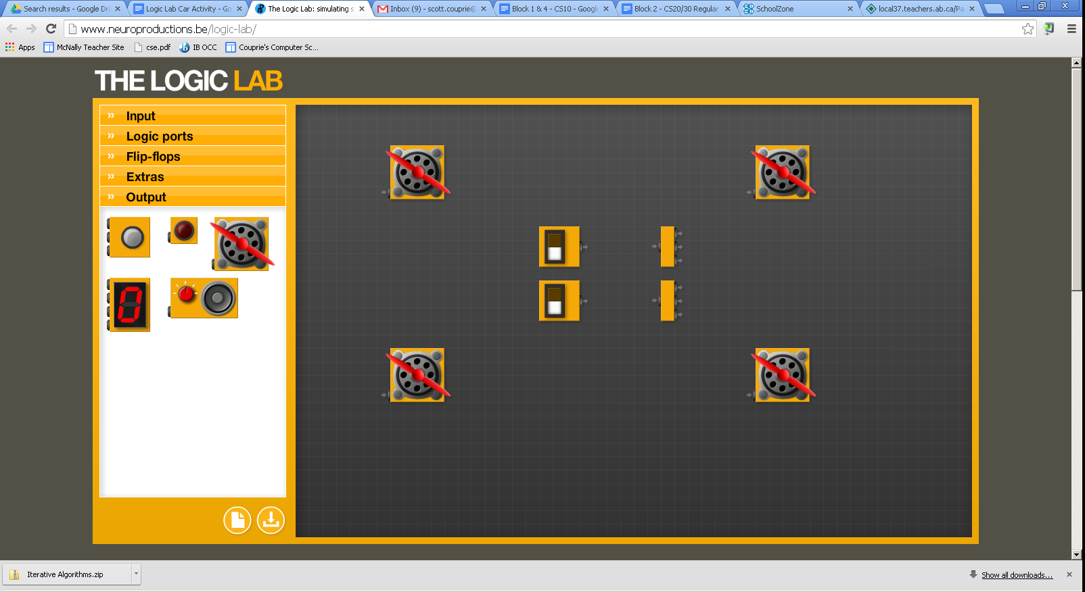
Assume the top pedal is the brake. The bottom is the gas.
Program the car with the following features:
- when the gas pedal is pressed (bottom switch), all four wheels start to spin (unless the brake is also pressed)
- when the brake is pressed, all four wheels will be stopped
- when the brake and gas is pressed, the engine should just rev (in other words, all four wheels will be stopped)
When finished use the “Snipping Tool” to screenshot your circuit solution. Insert the picture in Microsoft Word with Part 2 below for hand in.
Challenge #2: Turning
Building off your existing car, add 2 buttons (to act as the turn switches), 2 lights and a power pulser (plus possibly a splitter for the pulser). See picture below.
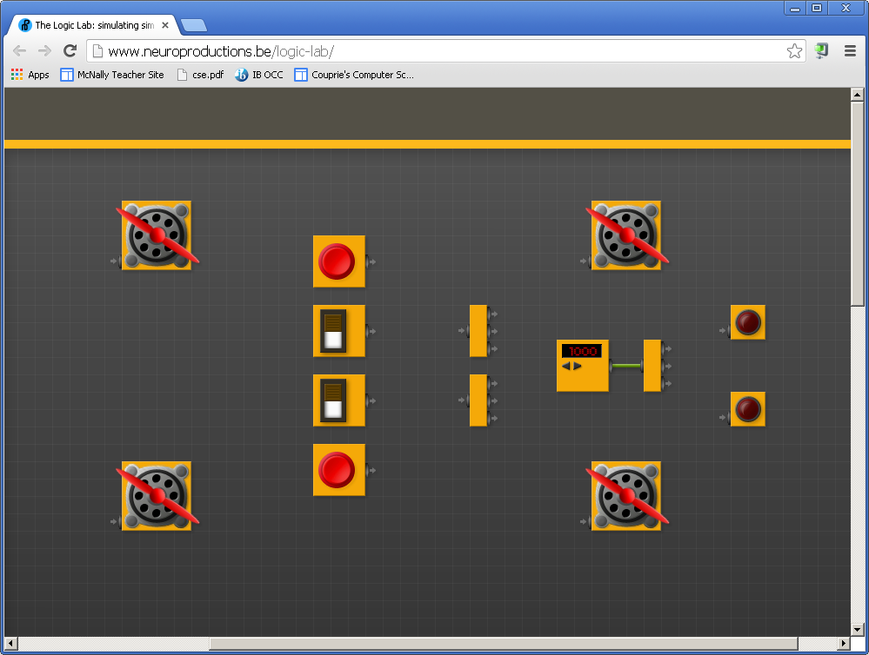
Turning will be indicated by having only 2 of the wheels spinning (like for a tank) and the appropriate light is on or flashing. Turning left will mean the top two wheels will be stopped. Turning right will mean the bottom two wheels will be stopped. Then program the car with the following features:
- when the gas pedal is pressed AND the right turn signal is on, the car will turn right (bottom wheels off, lower light flashing)
- when the gas pedal is pressed AND the left turn signal is on, the car will turn left
- if the gas pedal is not pressed, the turn signals will not do anything
- for this scenario, you do NOT need to worry about the cases where both signals are pressed or when both the brake and gas pedals are pressed

When finished use the “Snipping Tool” to screenshot your circuit solution. Insert the picture in Microsoft Word with Part 1 above for hand in.
Extra challenges:
Here are some fun things to try if you have time:
- add brake lights
- add a bumper that will turn off the engine in the event of a crash
- add a speedometer. Use multiple switches to represent how far down you are pressing the gas pedal and then wire in the counter to show your speed.
- add whatever else you can think of

