Introduction to Algorithms 1: Hello Processing
Watch and complete the following tutorial. Use the “Snipping Tool” to Capture the result of each of the exercises. Capture both the product and your code. http://hello.processing.org/
Part A: Shape
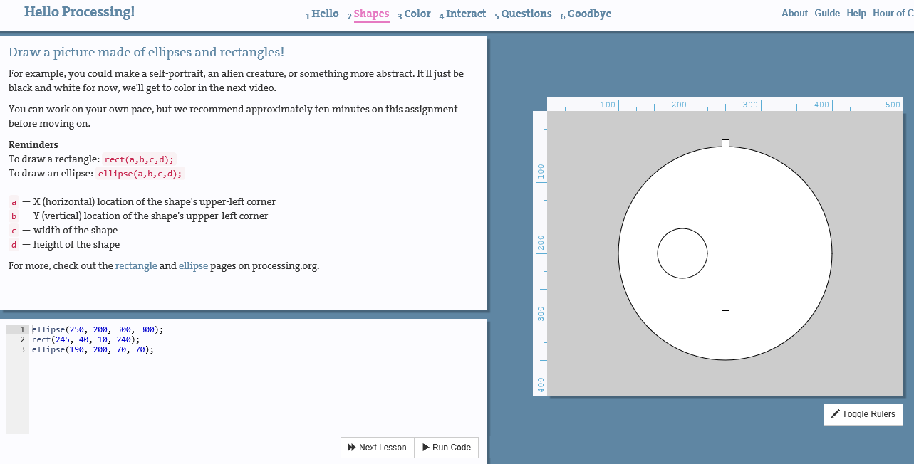
Part B: Color
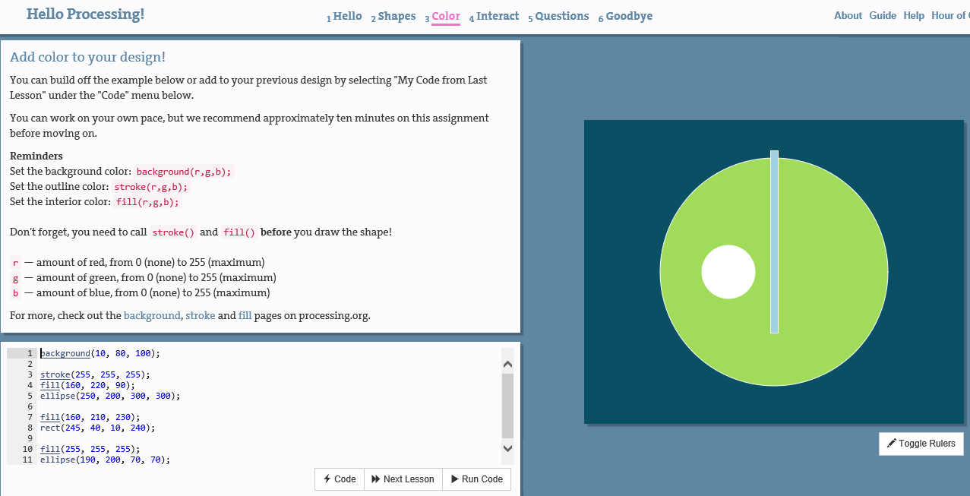
Part C: Interact
