Basic Algorithms Assignment:
Part A: Excel Algorithms
Excel is a common spreadsheet application, but many people do not fully utilize excel to perform powerful algorithms that are very similar to computer programming algorithms. Use excel to perform the following calculations.
- Find the Average of Two Numbers.
- Find the Maximum and Minimum values of a set of numbers.
- Find the Sum of a set of numbers.

- Copy and Paste the Excel Cells into a Word Document to hand in when done.
Part B: Java Algorithms
Java is a very popular programming language. It can be run in many environments. Today we are going to research how to do some simple calculations in Java. We will be using an online java compiler to test and run our code. The website we will be using is: http://ideone.com/
You will write your code below the comment line “// your code goes here”
Look at my simple example of how to add 2 numbers below: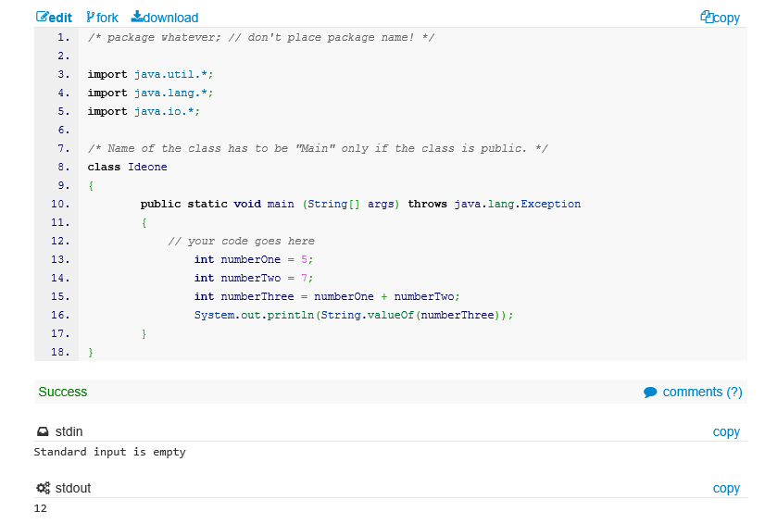
Using the internet research how to do the following simple calculations in Java:
- Find the Average of two numbers.
- Find the Sum of three numbers.
- Increment a number by one. (Bonus: Use a “for loop” to increment and print 5 times)
- Find the Minimum and Maximum values of an array of numbers (You may need teacher assistance for this one). See this link

- Use the “Snipping Tool” to screenshot your code and results. Insert the image into a Word Document for handin.

