**Arduino Servo Button Tutorial**

(<http://www.instructables.com/id/Servo-Controlled-by-Pushbuttons/>)

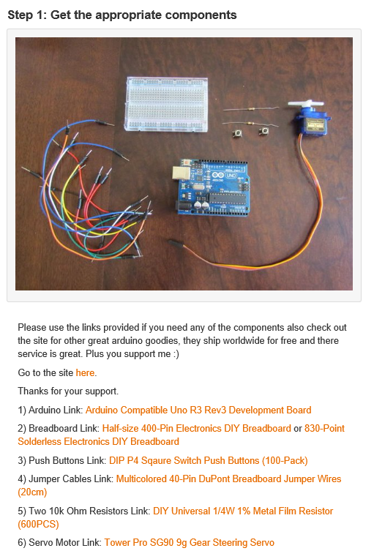  
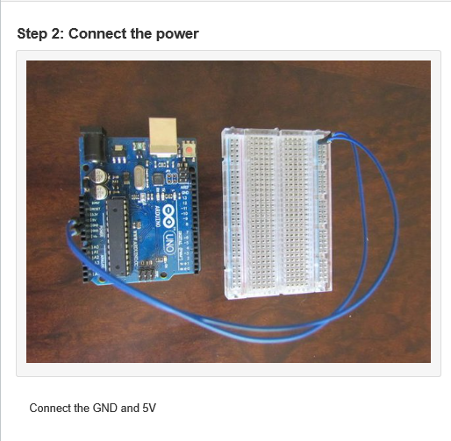

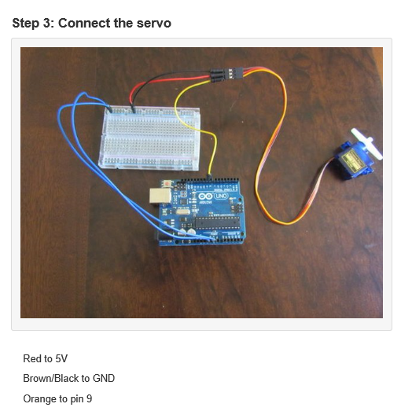

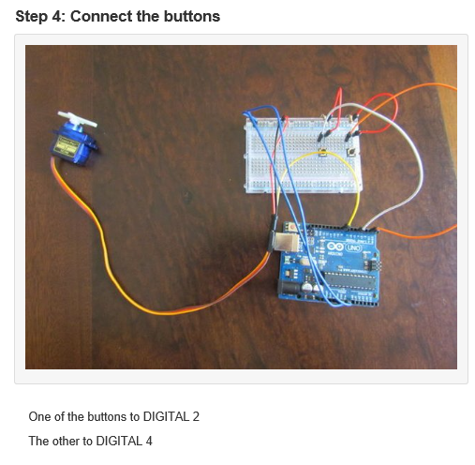

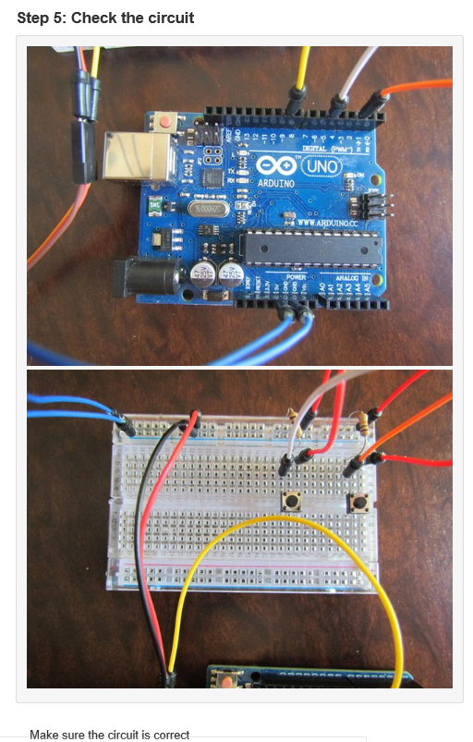

**Step 6: Enter the code and send it to your Arduino.**

Arduino Code:

#include <Servo.h>

const int buttonPin = 2;

const int buttonPin2 = 4;

int buttonState = 0;

int buttonState2 = 0;

Servo servoA;

int position = 0;

void setup() {

servoA.attach(9);

pinMode(buttonPin, INPUT);

pinMode(buttonPin2,INPUT);

}

void loop() {

buttonState = digitalRead(buttonPin);

buttonState2 = digitalRead(buttonPin2);

if(buttonState ==HIGH && position < 180){

servoA.write(position++);

delay(5);

}

if(buttonState2 == HIGH && position > 3){

servoA.write(position--);

delay(5);

}

}

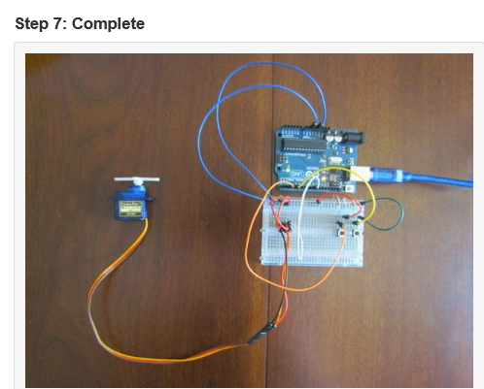

[Video Complete](https://youtu.be/eHd2XtVQdtM)

**Example Finished Project**

