CTF Design, Create and Appraise- Project Sheet
Name:
Instructions: Use this template as you work through each challenge/assignment in the course. Upon completion of each challenge/assignment, hand in this completed template along with your project. It should be saved in the format, “LastnameFirstNameAssign#”.

Design (Draft):
Instructions: Either complete a detailed draft of you plan to complete your project or list in point form the key components to successful completion of your challenge.

Create:
Instructions: Make sure your project is handed into the hand in folder in the format specified by your teacher named according to the following naming format “LastnameFirstnameAssign#”. List any adaptations that you needed to make to your design/draft below:
Adaptations:

Appraise:
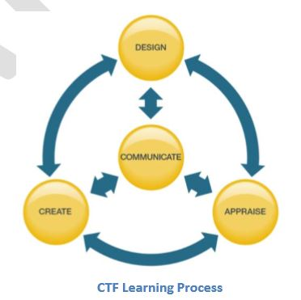
Instructions: In a short paragraph evaluate your project. Use your own personal feelings along with feedback from your peers. Evaluate the quality of your project, the effort you put into the project and the choices you made in the design process. Also include anything you would do differently if you were to do the project again which would make the project better or would help complete the project more efficiently.

Occupational Link: Link two occupations that may be involved in this type of project.

Environmental Concerns: List any environmental concerns that may need to be considered while completing this project.

In this project… | Check all that apply:
1 I explore my interests, passions and skills making personal connections to career possibilities.
2 I use occupational area skills, knowledge and technologies.
3 I follow safety requirements associated with occupational areas.
4 I demonstrate environmental stewardship associated with occupational areas.
5 I plan in response to challenges.
6 I make decisions in response to challenges.
7 I adapt to change and unexpected events.
8 I solve problems in response to challenges.
9 I create products, performances or services in response to challenges.
10 I appraise the skills, knowledge and technologies used to respond to challenges.
11 I communicate my learning.
12 I determine how my actions affect learning
13 I develop skills that support effective relationships.
14 I collaborate to achieve common goals.
CTF Project Checklist:

